# Overview

This document contains the necessary information to build, assemble, and test the device.

Overview 1

Maker To Do List 3

Items to Give to User 3

Customization Guide 4

Joystick 4

Toppers 4

Mounting 4

3D Printing Guide 5

3D Printing Summary 5

3D Printing Settings 5

Joystick Enclosure - REQUIRED 5

Oak Topper Interface – OPTIONAL, Required for Topper 5

Toppers* - OPTIONAL 5

Post-Processing 6

Examples of Quality Prints 6

Assembly Guide 8

Required Components 8

Required Tools 8

Optional Tools 8

Required Personal Protective Equipment (PPE) 9

Joystick Assembly 9

Step 1: Remove the Ring 9

Step 2: Prepare Audio Cable 9

Step 2: Identify Audio Cable Wires 10

Step 3: Prepare Wires 10

Step 4: Wire the Joystick 11

Step 5: Test the Wiring 14

Step 6: Insert and Align the Joystick into the Enclosure Top 15

Step 7: Rotate and Align the Joystick In the enclosure Top 15

Step 8: Screw the Joystick into the Enclosure Top 16

Step 9: Secure the Audio Cable 16

Step 10: Insert M3 Hex Nuts 17

Step 11: Assemble and Secure Enclosure 17

Step 12: Joystick Assembly Complete 18

Testing 18

Testing using a Multimeter 18

Testing using an USB-HID Gamepad Device 19

This list provides an overview of the steps required to build and deliver the device.

## Maker To Do List

* Read through the Maker Guide to become familiar with required components, tools, supplies, safety gear, and overall assembly steps.
* Ask the user if they would if they have a device to connect the joystick to.
  + Xbox Adaptive Controller
  + [Forest Joystick Mouse Hub](https://github.com/makersmakingchange/Forest-Joystick-Mouse-Hub)
  + [Enabled Controller Mini](https://github.com/makersmakingchange/Enabled-Controller-Mini/tree/main)
  + [Enabled Controller](https://github.com/milador/Enabled-Controller)
  + Other Analog to USB joystick hub
* Ask the user if they would like any joystick toppers.
* Ask the user if they would like a specific mounting solution.
* Talk to User about customization options (e.g., colour, any special requests, etc.).
* Order hardware components.
* 3D print all 3D printed components.
* Gather tools, supplies, and safety equipment.
* Assemble the device.
* Test device.
* Print “User Guide”

## Items to Give to User

* Assembled, tested device
* Any joystick toppers if requested.
* Any mount adapters if requested.
* “User Guide”

# Customization Guide

## Joystick

The enclosure can be printed in the user’s desired colour(s). Colour swaps can be done to further customize the joystick and make the forward arrow on the top stand out more.

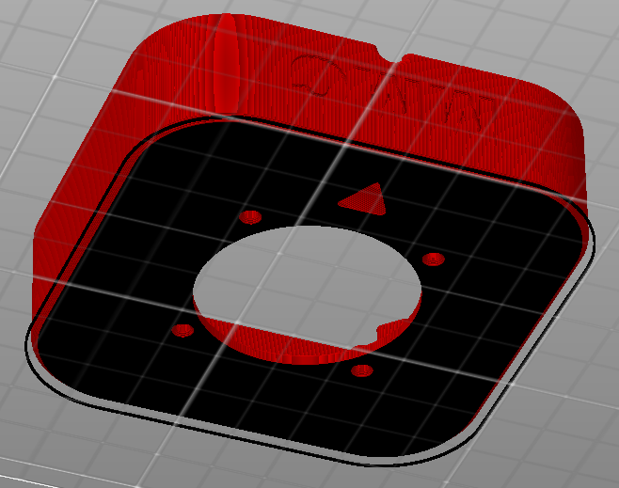

## Toppers

3D printed joystick toppers can be added to the joystick. Current topper type include ball, concave, convex, goalpost, and stick (shown left to right). Each comes in sizes small, medium, and large, which can be seen in the [Topper Guide](https://github.com/makersmakingchange/Oak-Compact-Joystick/tree/v1.0/Documentation/Working_Documents/Oak_Joystick_Topper_Guide.docx), or can be further modified through the [original design files](https://github.com/makersmakingchange/Oak-Compact-Joystick/tree/v1.0/Design_Files).

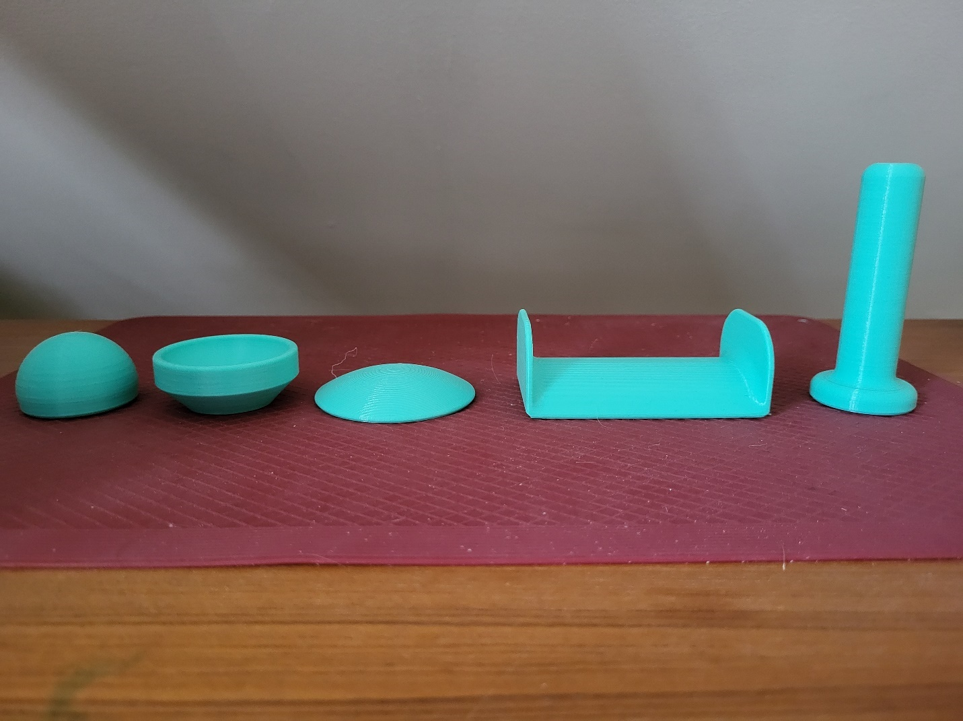

## Mounting

Mount adapters can be added for custom mounting solutions. Current mounting options include nonslip pads, hook and loop fastener, and a ¼-20 camera mount adapter. Further mounting instructions can be found in the [OpenAT Joystick Setup Guide](https://github.com/makersmakingchange/OpenAT-Joysticks/Resources/OpenAT_Joystick_Setup_Guide.pdf).

# 3D Printing Guide

## 3D Printing Summary

|  |  |  |
| --- | --- | --- |
| **Metrics** | **Joystick Enclosure** | **Topper Interface** |
| Total Print Time (min) | 4h4m | 0h56m |
| Total Number of Components | 2 | 2 |
| Typical Total Mass (g) | 51.9 | 5.68 |
| Typical Number of Print Setups | 1 | 1 |

## 3D Printing Settings

### Joystick Enclosure - REQUIRED

|  |  |  |  |  |  |  |  |
| --- | --- | --- | --- | --- | --- | --- | --- |
| **Print File Name** | **Qty** | **Total Print Time (hr:min)** | **Mass (g)** | **Infill (%)** | **Support (Y/N)** | **Layer Height/ Nozzle Diameter(mm)** | **Notes** |
| Oak_Enclosure_Top.stl | 1 | 2:22 | 28.98 | 20 | N | 0.2/0.4 |  |
| Oak_Enclosure_Bottom.stl | 1 | 1:42 | 22.81 | 20 | N | 0.2/0.4 |  |

### Oak Topper Interface – OPTIONAL, Required for Topper

|  |  |  |  |  |  |  |  |
| --- | --- | --- | --- | --- | --- | --- | --- |
| **Print File Name** | **Qty** | **Total Print Time (hr:min)** | **Mass (g)** | **Infill (%)** | **Support(Y/N)** | **Layer Height/ Nozzle Diameter(mm)** | **Notes** |
| Topper_Nut.stl | 1 | 0:39 | 4.64 | 20 | N | 0.2/0.4 |  |
| Collet.stl | 1 | 0:17 | 1.04 | 20 | N | 0.2/0.4 |  |

### Toppers* - OPTIONAL

|  |  |  |  |  |  |  |  |
| --- | --- | --- | --- | --- | --- | --- | --- |
| **Print File Name** | **Qty** | **Total Print Time (hr:min)** | **Mass (g)** | **Infill (%)** | **Support(Y/N)** | **Layer Height/ Nozzle Diameter(mm)** | **Notes** |
| Medium_Ball_Topper.stl | 1 | 1:16 | 17.98 | 10 | N | 0.2/0.4 | Print with 4 perimeters |
| Medium_Concave_Topper.stl | 1 | 1:07 | 14.69 | 10 | N | 0.2/0.4 | Print with 4 perimeters |
| Medium_Convex_Topper.stl | 1 | 0:42 | 8.63 | 10 | N | 0.2/0.4 | Print with 4 perimeters |
| Medium_Goalpost_Topper.stl | 1 | 1:30 | 17.14 | 10 | N | 0.2/0.4 | Print with 4 perimeters |
| Medium_Stick_Topper.stl | 1 | 3:13 | 49.57 | 10 | N | 0.2/0.4 | Print with 4 perimeters |

*Note that only the medium topper sizes are shown in the 3D printing Settings table. There are small and large sizes available, as well as the original Fusion 360 files that can be modified to specific dimensions.

## Post-Processing

* Remove any supports from the Camera mount adapter if it is printed.
* Clear any stringing in the collet if it is printed.

## Examples of Quality Prints

**Photos of Enclosure 3D Prints**

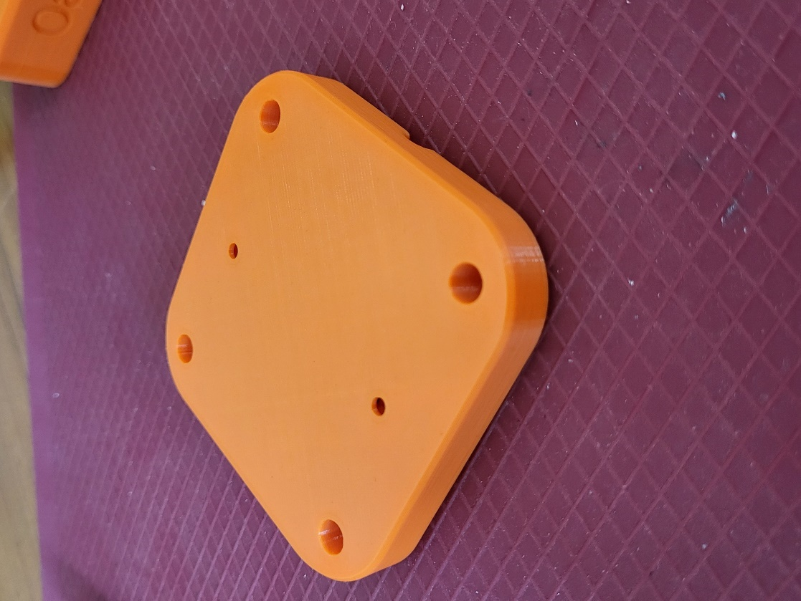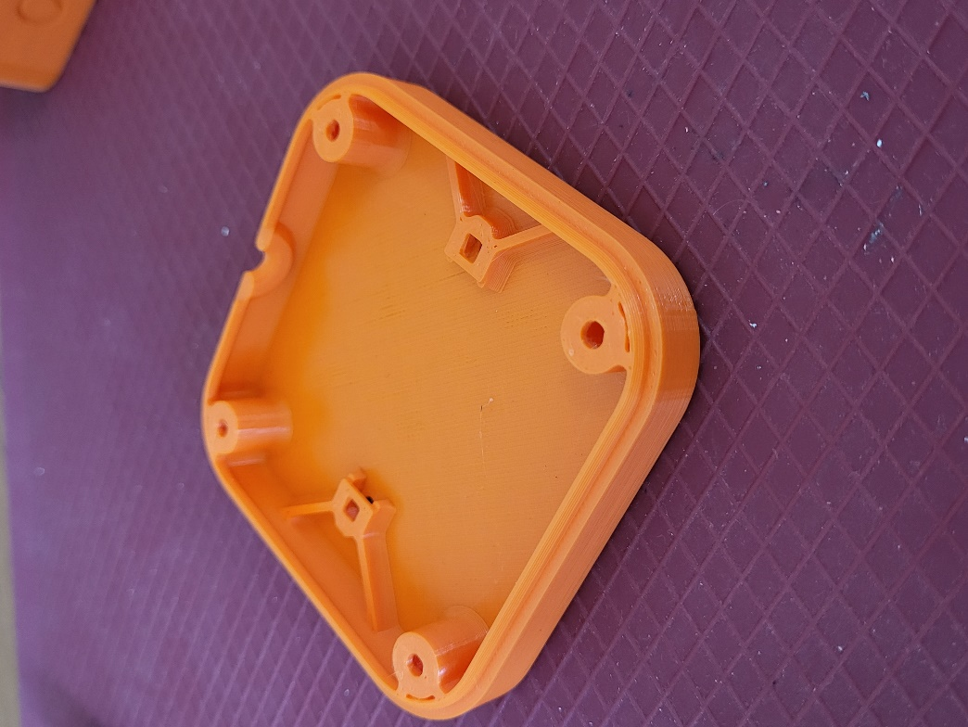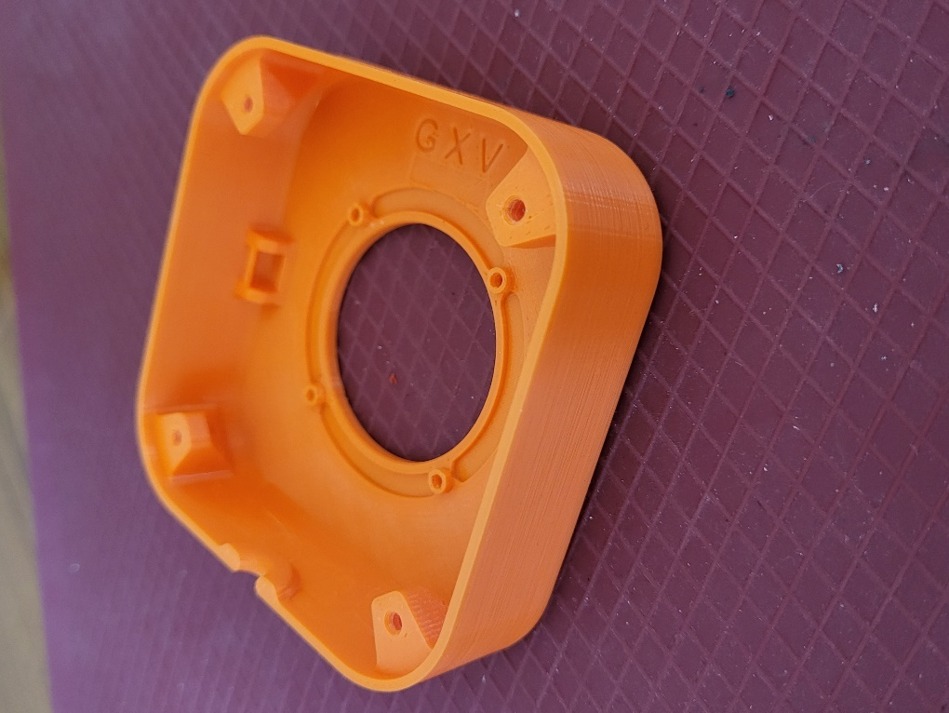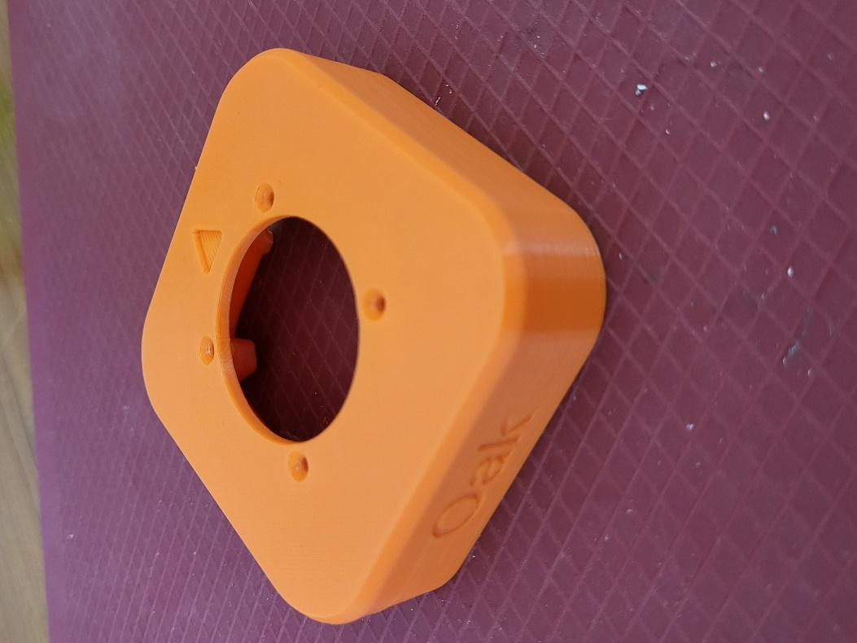

**Photos of Topper 3D Prints**

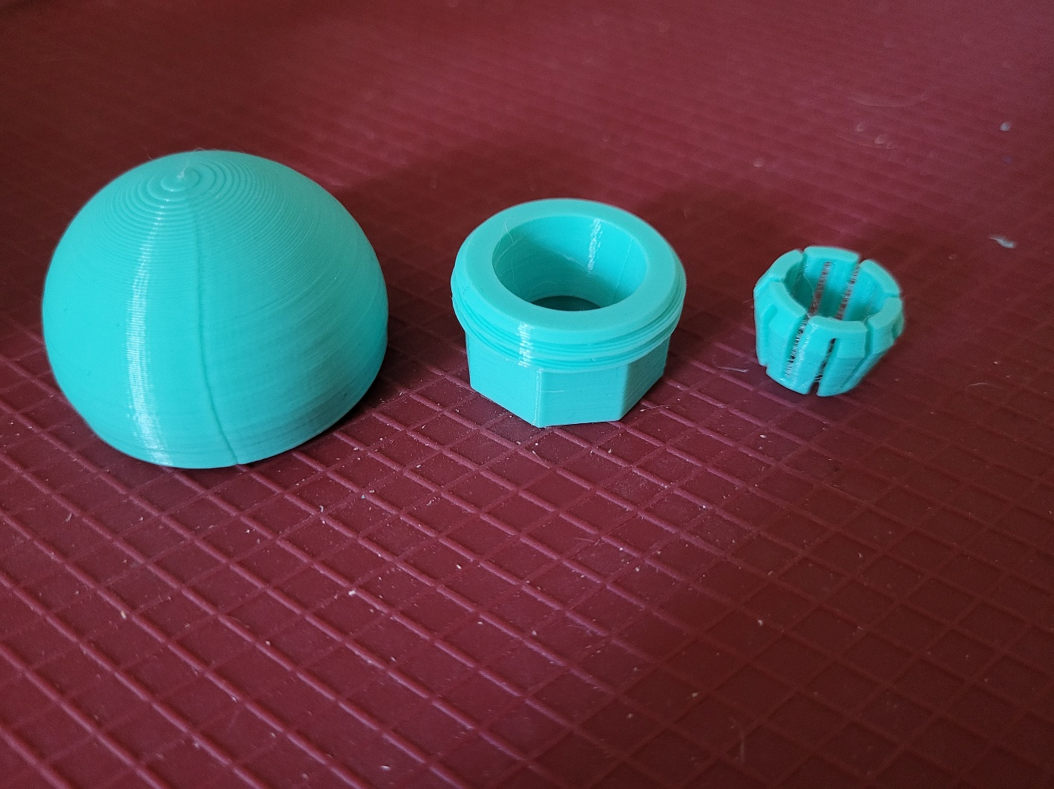

# Assembly Guide

## Required Components

|  |  |  |  |  |  |  |  |  |
| --- | --- | --- | --- | --- | --- | --- | --- | --- |
| **1** | Joystick Unit | QTY 1 | **2** | TRRS Audio Cable | QTY 1 | **3** | 26 AWG Wire | QTY 1ft |
| A photo of the joystick unit required for this build. | | | A photo of the TRRS audio cable required for this build. | | | A photo of the 26 AWG wire required for this build. | | |
| **4** | #4 3/8” Screws | QTY 4 | **5** | 4” cable tie | QTY 1 | **6** | M3 Hex Nuts | QTY 2 |
| A photo of the #4 3/8" required for this build. | | | A photo of the cable tie required for this build. | | | A photo of the M3 nuts required for this build. | | |
| **7** | 3D Printed Enclosure Top | QTY 1 | **8** | 3D Printed Enclosure Bottom | QTY 1 |
| A photo of the exterior of the enclosure top printed in orange PLA. | | | A photo of the interior of the enclosure bottom printed in orange PLA. | | |

## Required Tools

* #3 Phillips Screwdriver
* Wire Cutters
* Wire Strippers
* Soldering Iron and Solder
* Multimeter (with continuity testing capabilities)

## Optional Tools

* Tweezers

## Required Personal Protective Equipment (PPE)

* Safety Goggles

## Joystick Assembly

### Step 1: Remove the Ring

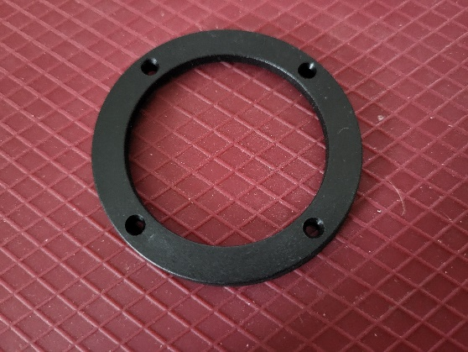The Adafruit Mini Analog Joystick comes with a ring that screws into the top. You **will not need** this ring and can dispose of it.   
  
**Note:** Keep the screws that come with the joystick, do not throw them out.

### Step 2: Prepare Audio Cable

If you are using the pre-prepared TRRS cable from DigiKey, pictured in the component list, you can skip this step.

If using a different cable, you’ll need to prepare the wires for soldering. Cut the TRRS cable to length (typically 1 m). Strip off approximately 3 cm of the outer insulation. Then separate the individual inner wires and strip off approximately 0.5 cm of insulation.

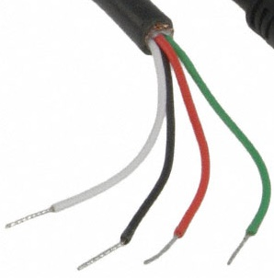

### Step 2: Identify Audio Cable Wires

If using the pre-prepared DigiKey cable, you can skip this step.

If using a different cable, you need to identify which wires correspond to which parts of the plug. Use a multimeter or other continuity tester to confirm. Follow this [guide for checking continuity](https://www.youtube.com/watch?v=T4p8UQZqh5U) to determine which wire corresponds to the Sleeve, Ring 1, Ring 2, and Tip of the TRRS cable plug.

|  |  |  |
| --- | --- | --- |
| TRRS Plug | Digikey cable | Your cable |
| Tip (T) | Red |  |
| Ring 1 (R1) | White |  |
| Ring 2 (R2) | Green |  |
| Sleeve (S) | Black |  |

### Step 3: Prepare Wires

Cut two pieces of wire, 7 cm long. Strip 1 cm off the ends of both wires. Twist each respective end of the wires to collect all the frayed wire strands into one. Choose one to be Wire A, and one to be Wire B.

Note: For this assembly guide, the yellow wire is Wire A and the blue wire is Wire B.

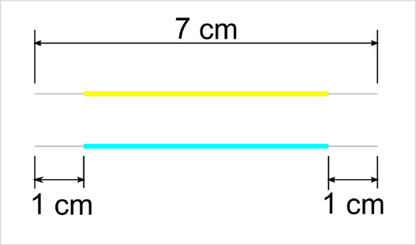

### Step 4: Wire the Joystick

Wiring the joystick will follow the diagram below and will be broken down into multiple steps. With the joystick positioned with the two potentiometers facing you as shown, the pins are numbered 1 through 6 from left to right.

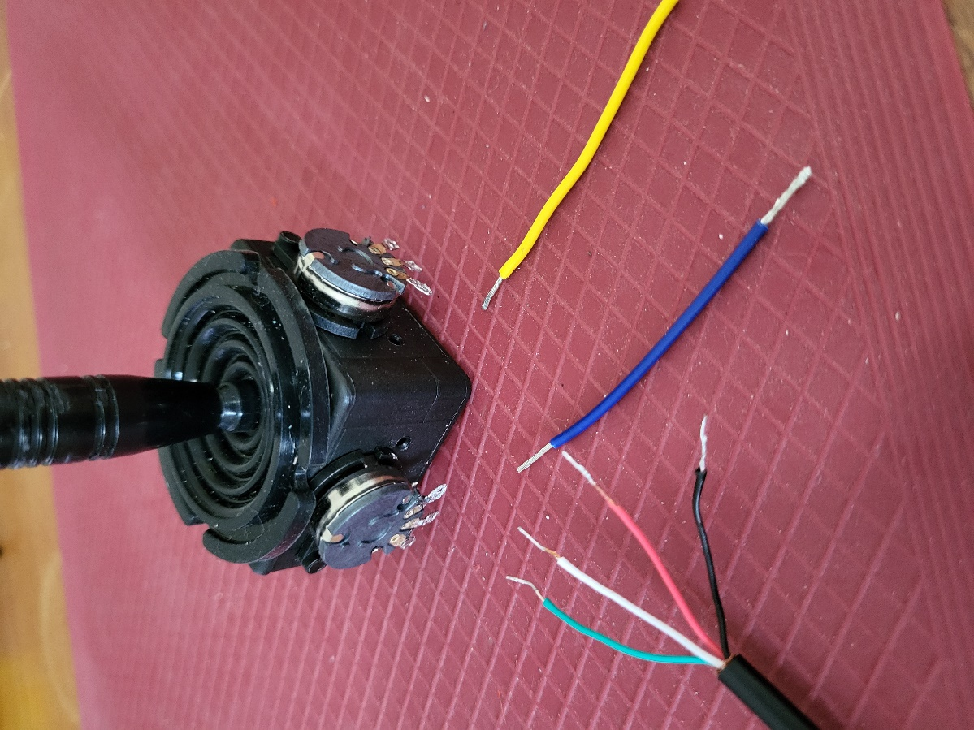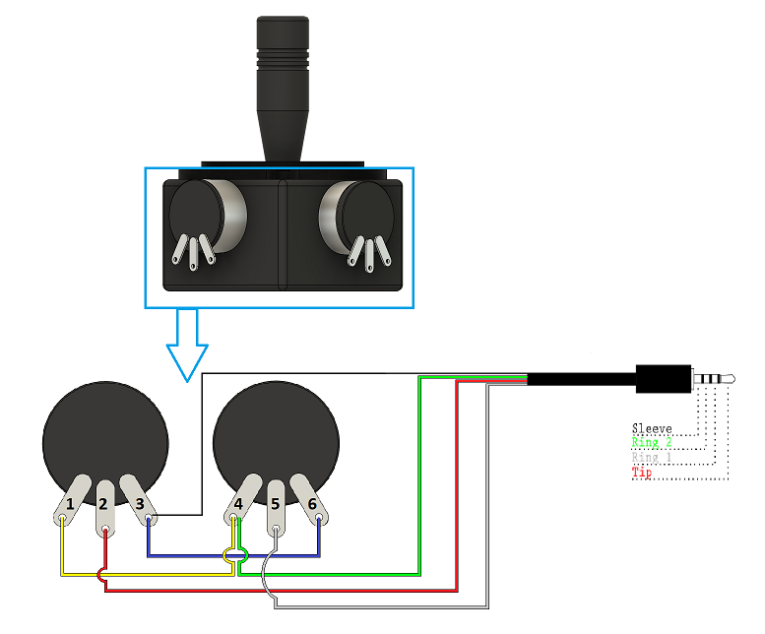

Image Remixed from [Sparkfun](https://www.sparkfun.com/products/11580), released under a [CC BY 2.0 license](https://creativecommons.org/licenses/by/2.0/).

|  |  |  |  |  |
| --- | --- | --- | --- | --- |
| Potentiometer Pins | CONNECTION | Digikey TRRS Cable | Your TRRS Cable | Extra Wire |
| 1 | PIN 4 | --- | ----- | Wire A |
| 2 | Tip (T) | Red |  | ---- |
| 3 | Sleeve (S) | Black |  | Wire B |
| 4 | Ring 2 (R2) | Green |  | Wire A |
| 5 | Ring 1 (R1) | White |  | ---- |
| 6 | PIN 3 | ---- | ---- | Wire B |

#### Step 4a: Wire and Solder Pin 1

Take Wire A and insert one end into Pin 1. Solder this into place.

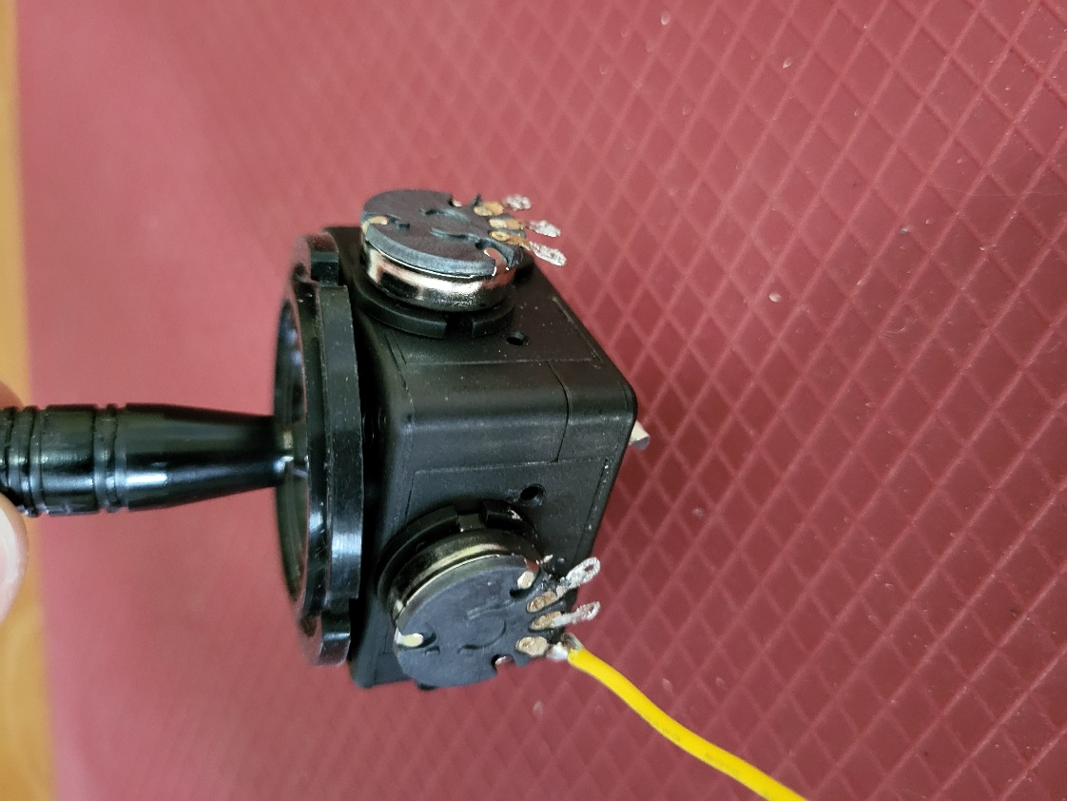

#### Step 4b: Wire and Solder Pin 2

Take the red (tip) wire from the audio cable and insert it into pin 2. Solder this into place.

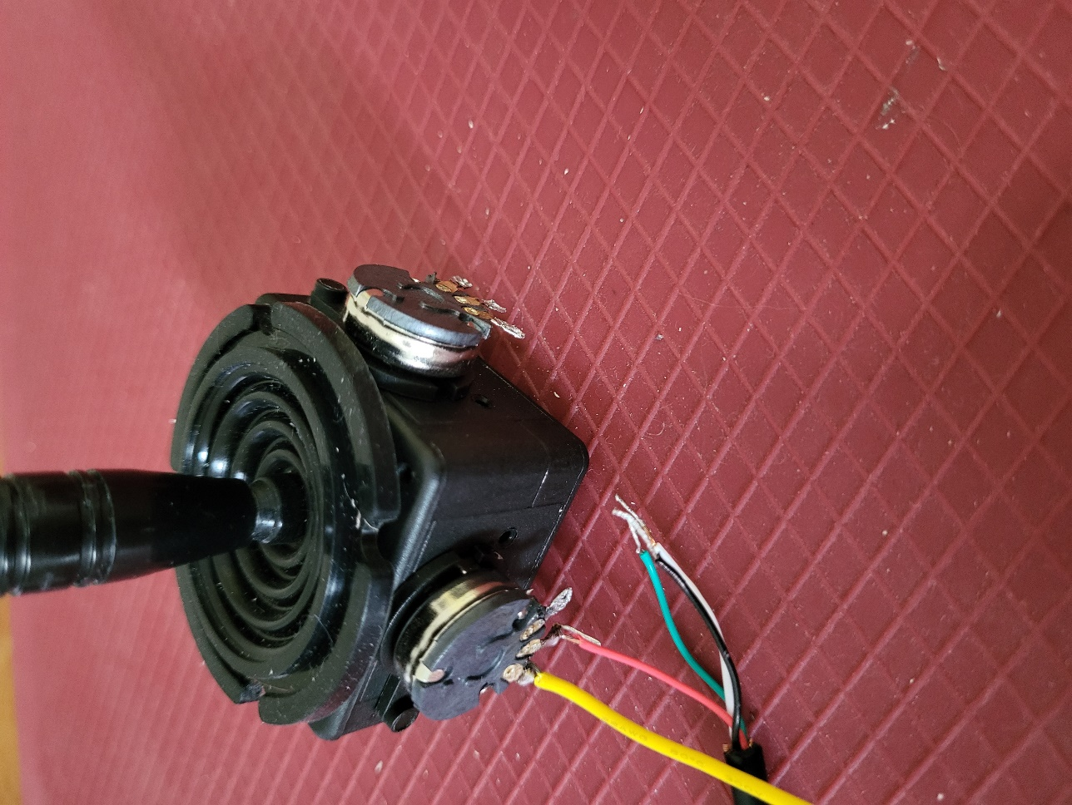

#### Step 4c: Wire and Solder Pin 3

Take the black (sleeve) wire from the audio cable and twist it together with one end of Wire B. Insert the twisted together portion of the wires into pin 3. Solder this into place.

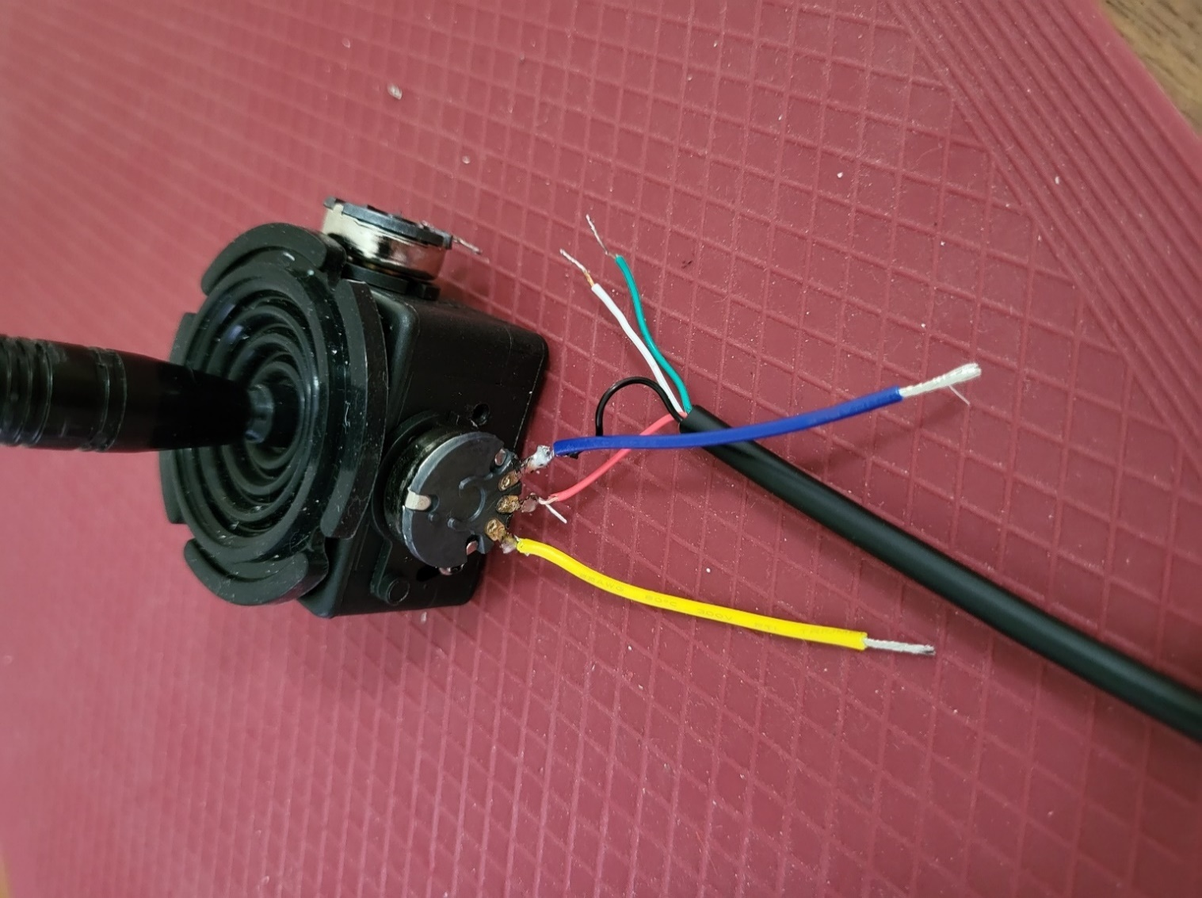

#### Step 4d: Wire and Solder Pin 4

Take the free end of Wire A and twist it together with the green (Ring 2) wire from the audio cable. Insert these into pin 4 and solder into place.

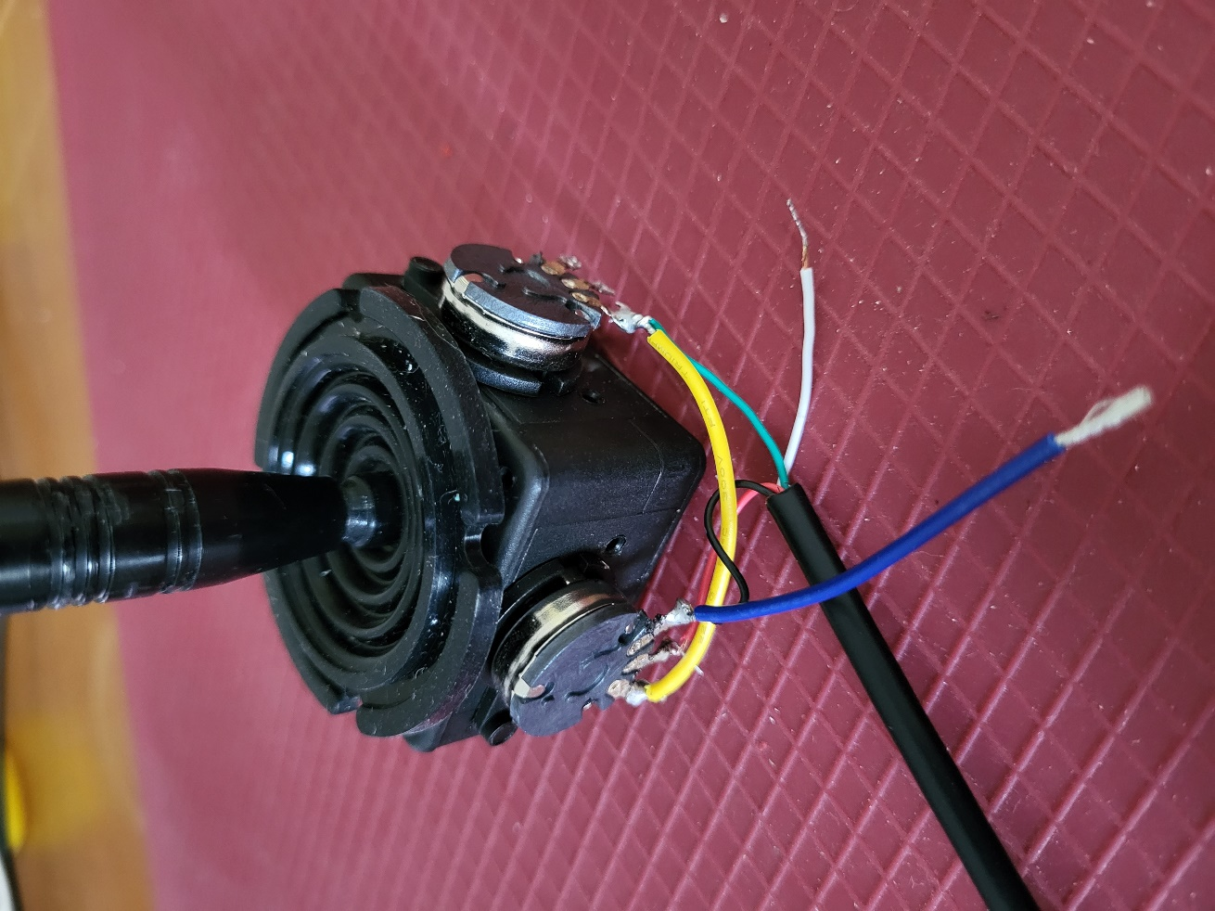

#### Step 4e: Wire and Solder Pin 5

Take the white (Ring 1) wire from the audio cable and insert it into pin 5. Solder this into place.

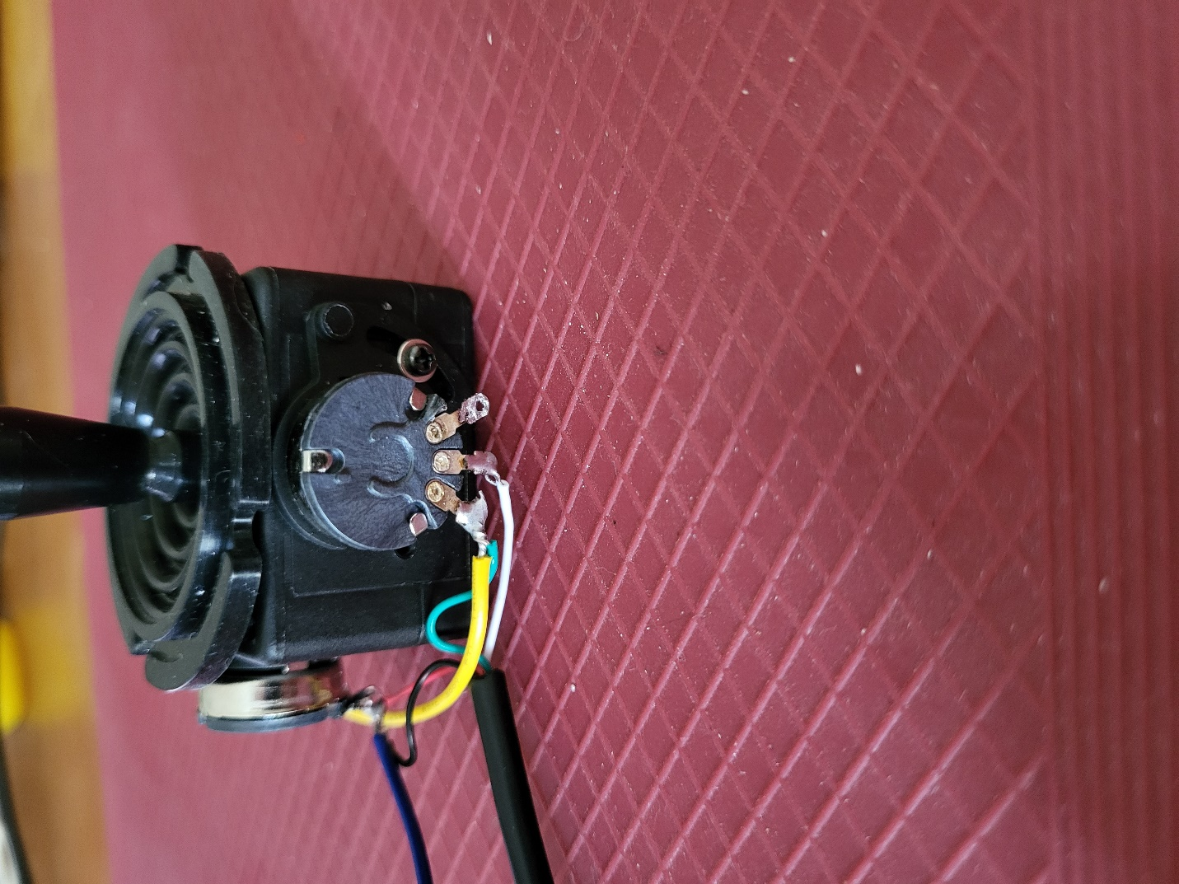

#### Step 4f: Wire and Solder Pin 6

Take the free end of Wire B and insert it into pin 6. Solder this into place.

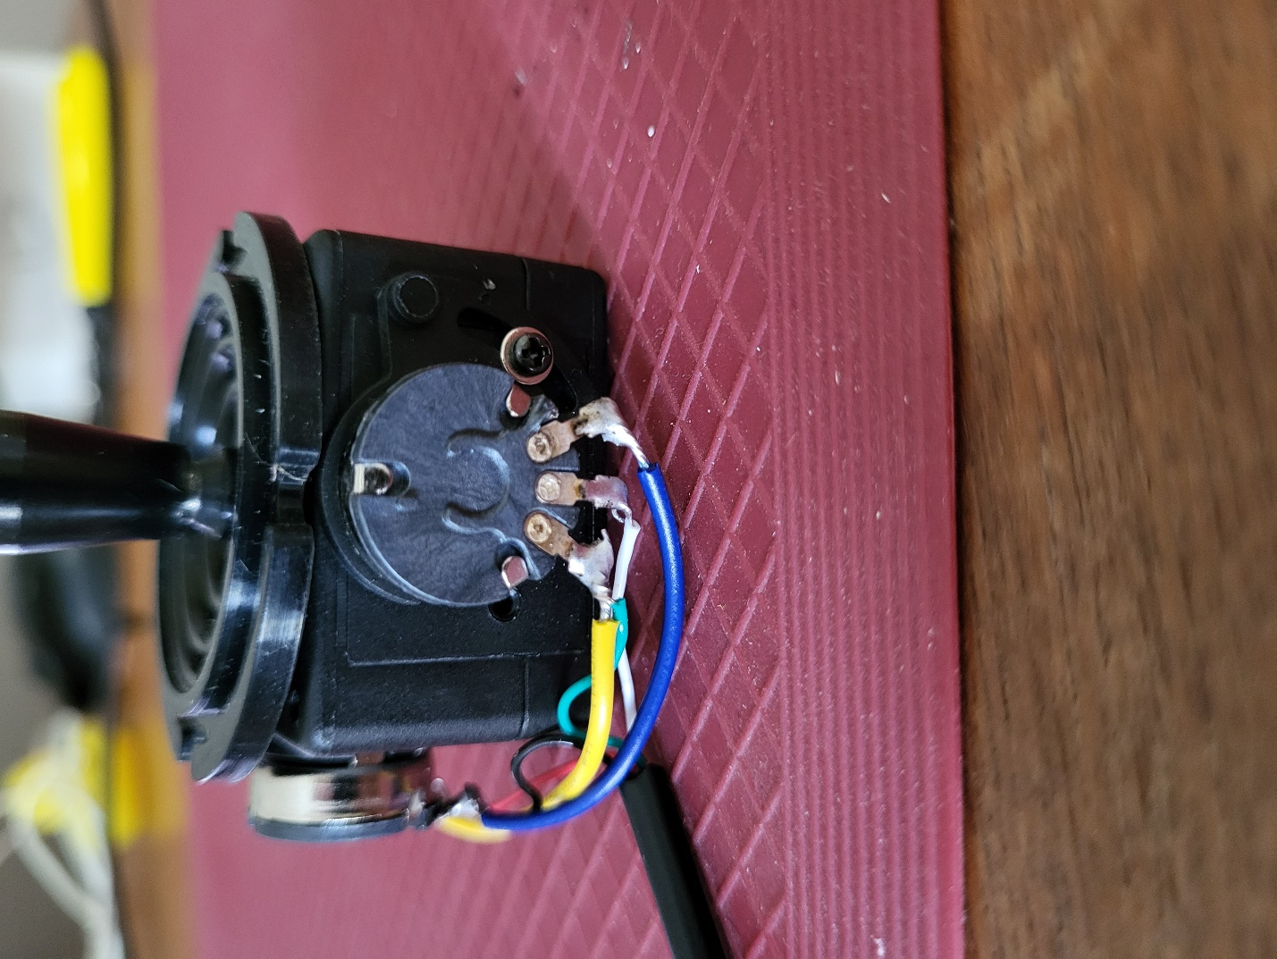

### A warning icon.Step 5: Test the Wiring

Visually inspect the wiring to ensure that the solder connects only the correct wires to the correct pins. If the solder is connecting anything it should not, use the soldering iron and some extra wire, solder wick, or a desoldering tool to remove solder from that area.

You can also use a multimeter to test continuity.

### Step 6: Insert and Align the Joystick into the Enclosure Top

Insert the joystick into the enclosure. Makre sure the rubber grommet fits into the grooves. There are 4 posts on the inner surface of the enclosure that the grommet should naturally align with. These posts will line up with the screw holes in the corners of the joystick.

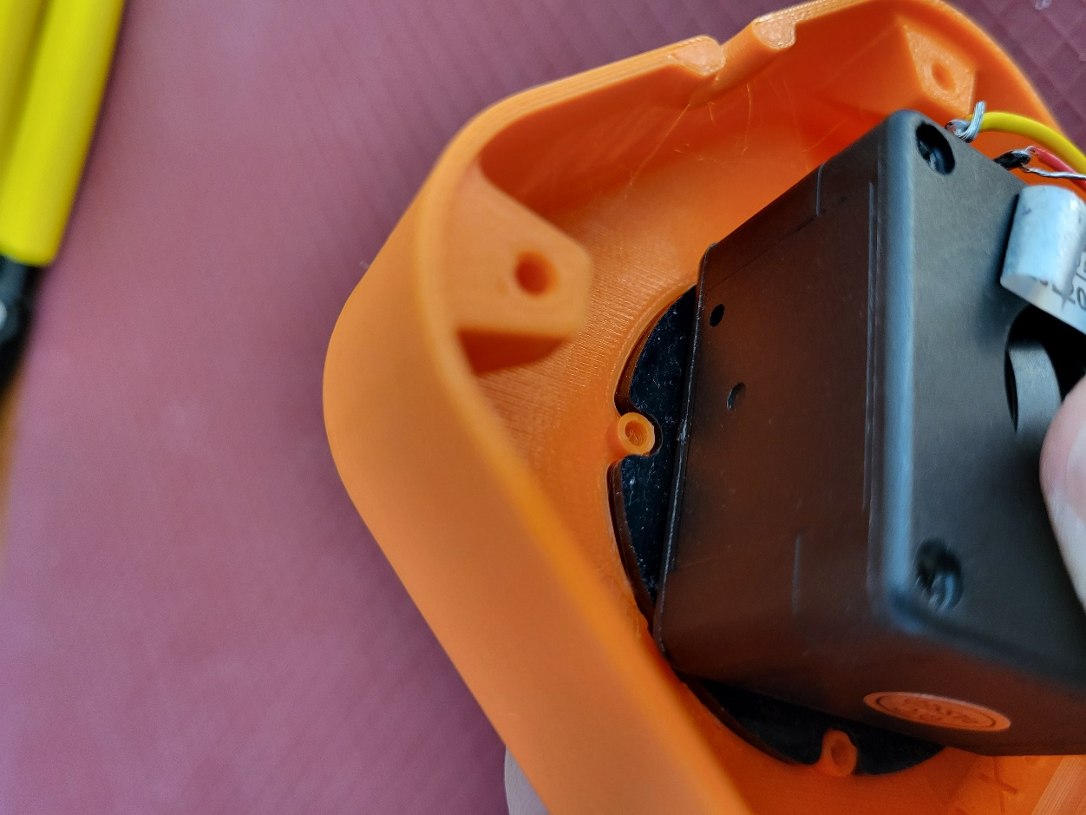

### Step 7: Rotate and Align the Joystick In the enclosure Top

While keeping the rubber grommet in place, rotate the base of the joystick so that the rectangular engravings on the inside surface match with the potentiometers on the joystick.

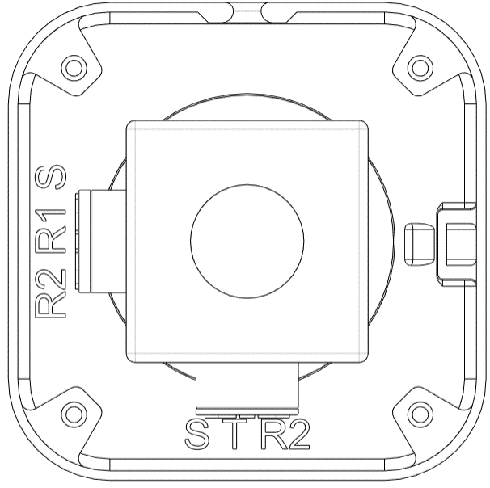

Cable Opening

Labels

Potentiometers

### Step 8: Screw the Joystick into the Enclosure Top

Insert the screws that came with the joystick unit in through the top of the enclosure and screw into the joystick. It is easiest to line up one corner to start, screw it in, and then proceed with the corner diagonally opposite. The remaining two corners will then be lined up to screw in.

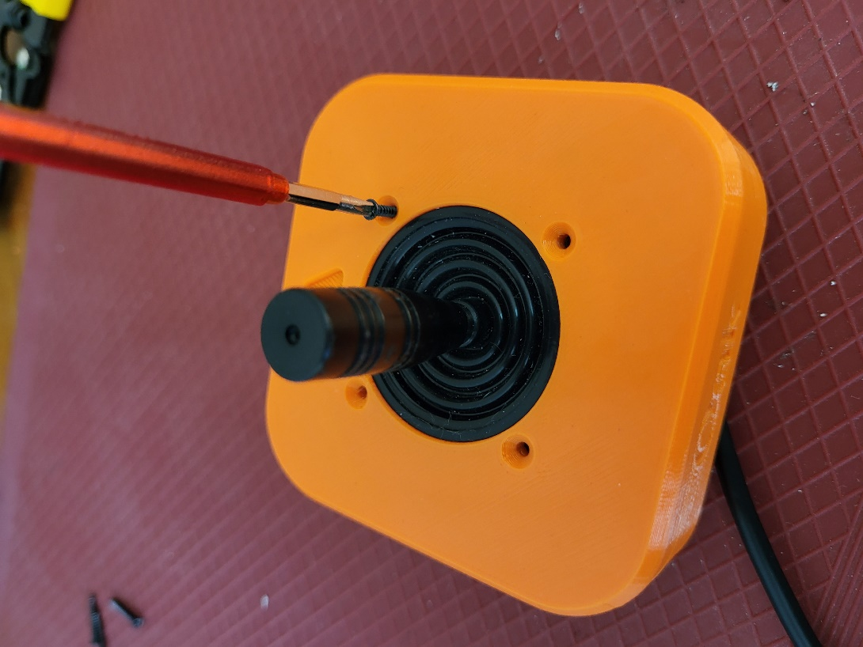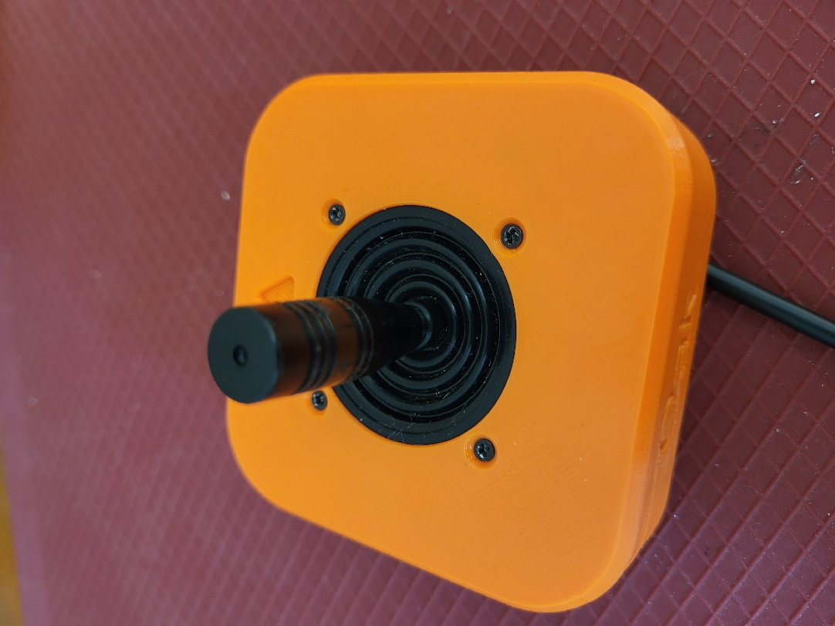

### Step 9: Secure the Audio Cable

Route the audio cable counterclockwise around the joystick and out the opening in the front of the joystick. Insert the cable tie down through the cable tie anchor and sinch it tight around the audio cable. Trim the end of the cable tie.

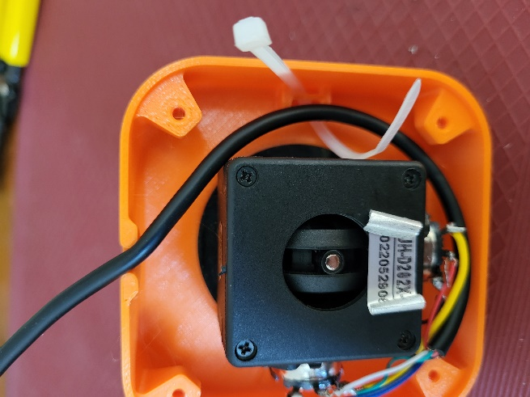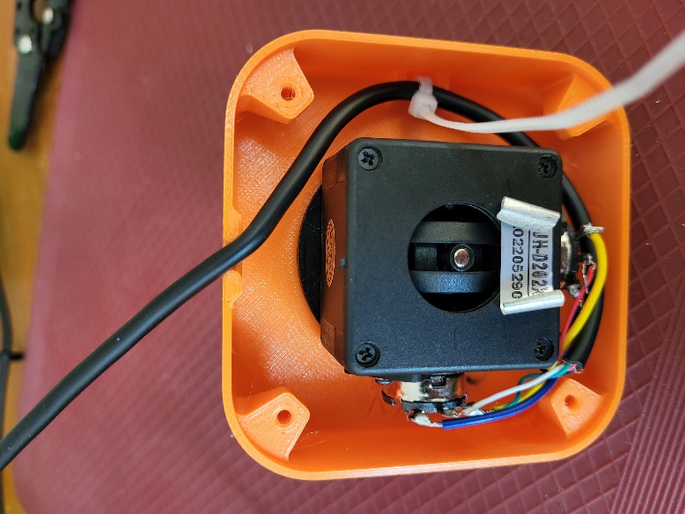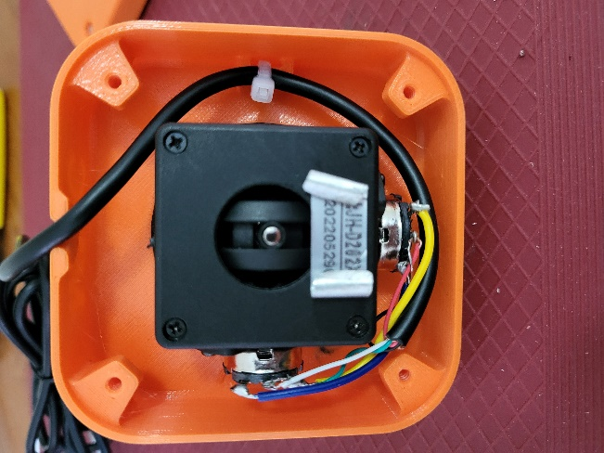

### Step 10: Insert M3 Hex Nuts

Take the enclosure bottom and insert the M3 nuts into the as shown. You may require a tool such as needle-nosed pliers or a screwdriver to push the nuts into place.

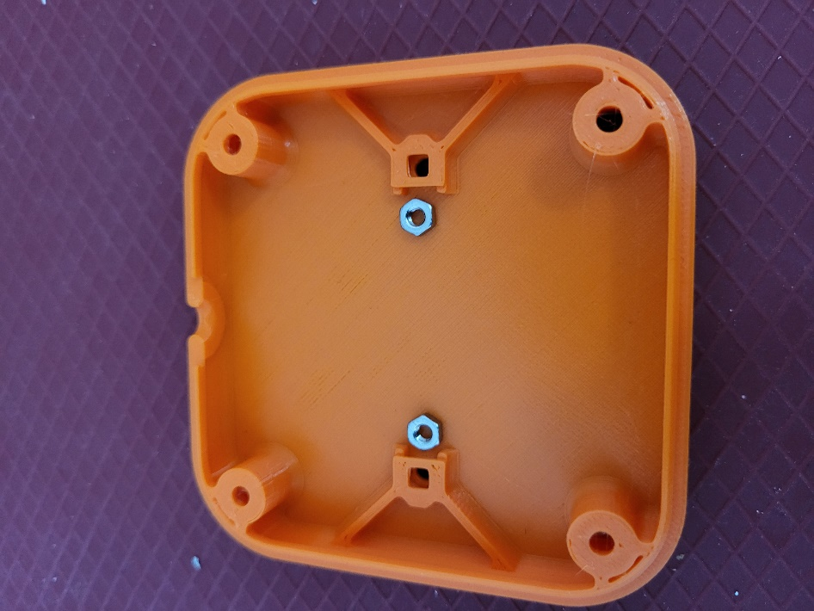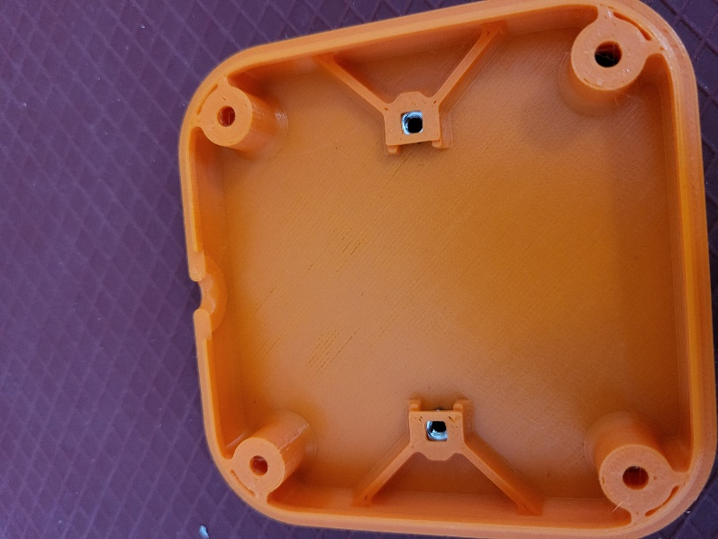

### Step 11: Assemble and Secure Enclosure

Line up the enclosure top and bottom so that the hole on the front walls line up for the audio cable to pass through. Insert the #4 3/8” screws up through the four corners of the bottom and tighten each.

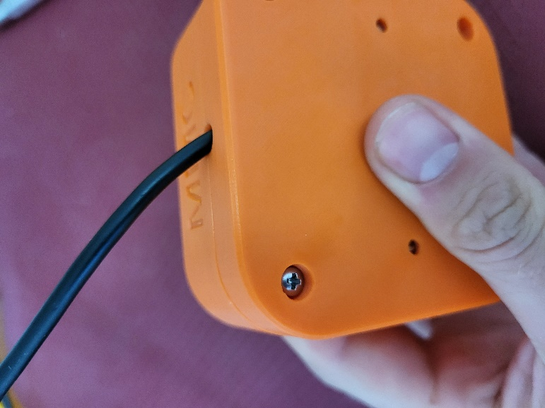

Corner screw holes

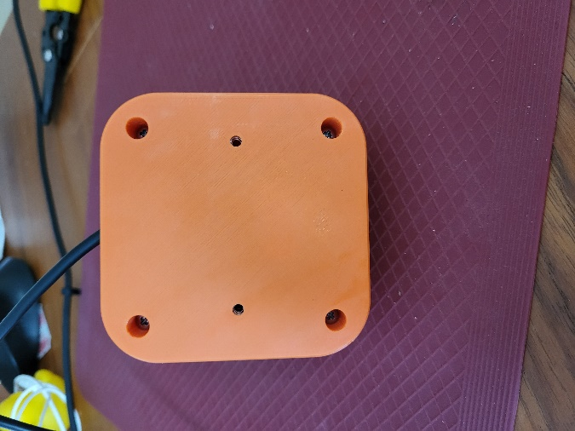

### Step 12: Joystick Assembly Complete

The joystick assembly is now complete.

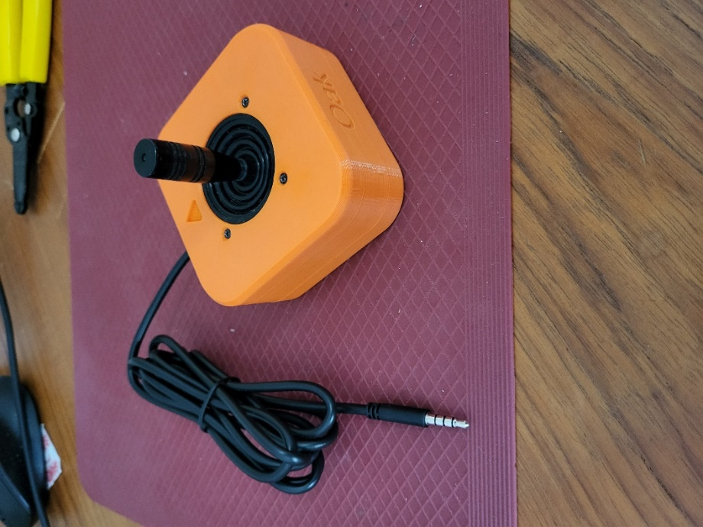

# Testing

Now that you have your completed Oak Joystick, you must test to make sure it is wired and assembled correctly. This can be done with a multimeter, or by plugging the joystick into one of the following: Forest Hub, Xbox Adaptive Controller (XAC), Enabled Controller Mini, Enabled Controller, or other USB-HID controller that accepts the input of an analog joystick and connecting to a computer.

## Testing using a Multimeter

A multimeter can be used to test if the wires are connected and soldered correctly. It is most important to ensure that there is no short circuit between the Sleeve (Ground) and Tip (Voltage), as this can damage the host device. It can be tricky to place the probes and move the joystick, so tape, or a second person can be helpful here.

### Test 1: Testing for Short Circuits

1. Set the multimeter to measure resistance in the 1-10 KΩ range.

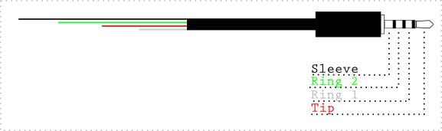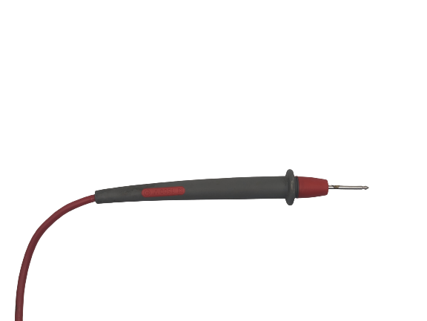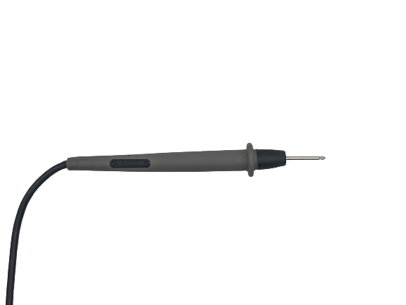

1. Hold the tip of the red probe of the multimeter to the Sleeve (Voltage) of the TRRS cable.
2. Hold the tip of the black probe of the multimeter to Ring 2 (Ground) on the TRRS cable.
3. Confirm that the resistance is between 4 – 5 KΩ.
   1. Between 4 – 5 KΩ: No shorts. Proceed to next test.
   2. Less than 50 Ω: There is a short circuit between a Ground and Voltage pin (Pins 1, 3, 4, and 6). This must be fixed to prevent damaging a host device. Open the joystick and review/fix your soldering joints.
   3. Other values: There is a wiring problem. Open the joystick and review/fix your soldering joints.

If you have no short circuits, you can move on to testing the joystick directions. This can be done with either the multimeter, or with a USB-HID gamepad that accepts an analog joystick.

### Test 2: Testing Vertical Joystick Axis

1. Hold the tip of the red probe of the multimeter to the Sleeve (Voltage) of the TRRS cable.



1. Hold the tip of the black probe to Ring 1 (Y-axis) on the TRRS cable.
2. While holding the multimeter probes in place, move the joystick fully in the UP ↑ direction.
   1. You may require a second person to hold the probes in place or move the joystick.
   2. Otherwise, the joystick can be held in place with some tape to leave your hands free to hold the multimeter probes in place.
3. Read the resistance on the multimeter:
   1. Less than .05 KΩ: The Y-axis potentiometer is wired correctly.
   2. Otherwise, review the wiring diagram and ensure your wiring matches.
4. Release the joystick back to neutral position.

### Test 3: Testing Horizontal Joystick Axis

1. Hold the tip of the red probe of the multimeter to the Sleeve (Voltage) of the TRRS cable.



1. Hold the tip of the black probe to Tip (X-axis) of the TRRS cable.
2. While holding the multimeter probes in place, move the joystick fully in the RIGHT → direction.
   1. You may require a second person to hold the probes in place or move the joystick.
   2. Otherwise, the joystick can be held in place with some tape to leave your hands free to hold the multimeter probes in place.
3. Read the resistance on the multimeter.
   1. Less than .05 KΩ: The X-axis potentiometer is wired correctly.
   2. Otherwise, review the wiring diagram and ensure your wiring matches.
4. Release the joystick back to neutral position.

**Note:** The intended joystick for this build has two 10 KΩ potentiometers, but some joysticks use 5 KΩ potentiometers, which will result in the expected multimeter readings to be halved.

### Troubleshooting

If tests 2 or 3 fail, here are the likely scenarios to address.

#### Test 2 Fail

If the multimeter reading does not decrease when moving the joystick from the neutral position the UP direction, then the Voltage and Ground pins (Pins 4 and 6) are opposite and need to be swapped.

If the multimeter reading does not change, then the X and Y axis pins (2 and 5) are opposite and need to be swapped.

#### Test 3 fail

If the multimeter reading does not decrease when moving the joystick from the neutral position the RIGHT direction, then the Voltage and Ground pins (Pins 1 and 3) are opposite and need to be swapped.

If the multimeter reading does not change, then the X and Y axis pins (2 and 5) are opposite and need to be swapped.

## Testing using an USB-HID Gamepad Device

Before plugging the joystick into a USB-HID Gamepad Device, ensure that there is no short circuit between the Tip and the Sleeve.

1. Plug the joystick into analog joystick input for the host device.
   1. X1 or X2 on an Xbox Adaptive Controller.
2. Plug the host device into your laptop.
3. If using Windows, open “Set up USB Game Controllers” from the Control Panel. You can find this by searching your computer in the search bar next to the Windows icon.
   1. If using a Mac, use <https://hardwaretester.com/gamepad>
4. Select the host device from the list of controllers and go to “Properties”.
5. Move your joystick and observe the movement of the cross hatch in the “Axes” window. Ensure it moves in the proper directions when you move the joystick (the arrow points in the up direction). If not, open the joystick and check your connections.